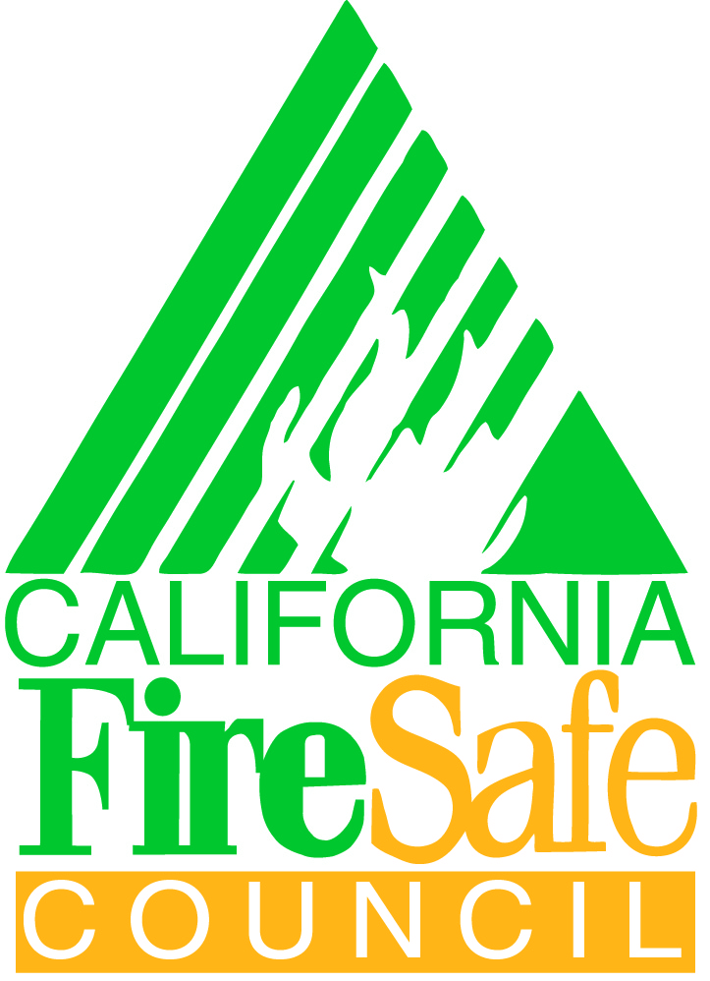
California Fire Safe Council

Grant Writing Workshop
(Please Sign In)
April 14th, 2011 Clovis, CA
Name | Organization | Email Address

