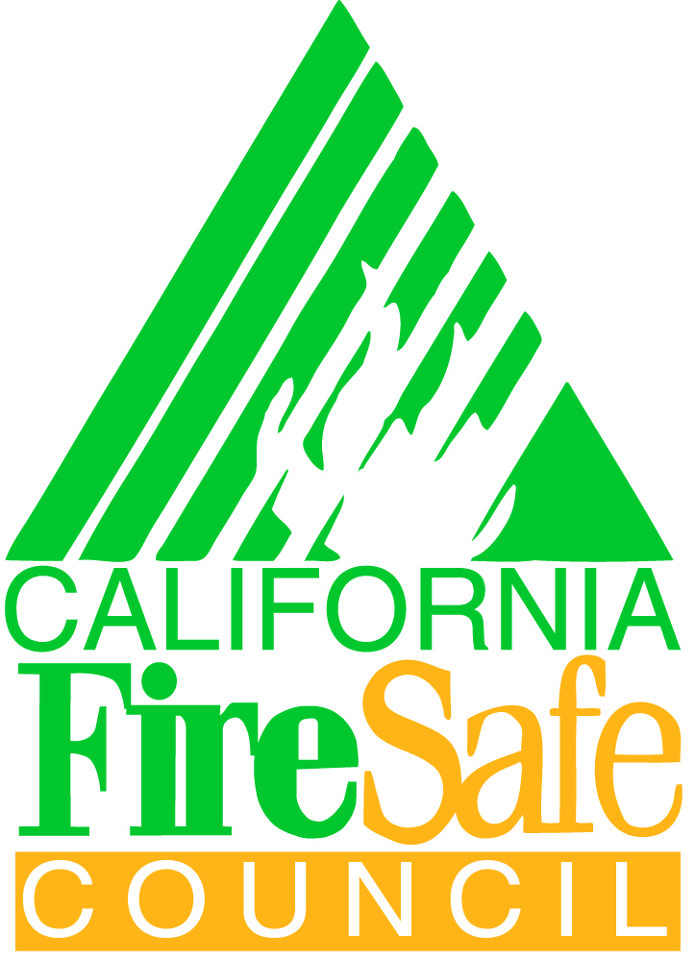
CFSC BOARD OF DIRECTORS MEETING
PUBLIC SESSION
December 9, 2015
WILDFIRE TRAINING CENTER- MCCLELLAN (SACRAMENTO)

The following directors were present:. Dave Bischel, Kate Dargan, Jerry Davies, David Horne , Pat Kidder, J.Lopez, Dave Shew, Frank Stewart, Bruce Turbeville, Jay Watson, and Troy Whitman.
The following directors were excused: Niel Fischer and Pat Frost.

The following members of staff were present: Dan Lang, Amber Gardner, Liron Galliano, Anne Pandey and Alex Horangic.
The following guests were present: Brian Barette (Society of American Foresters)
-------------------------------------------------------------------------------------------------------------------------------
CALL TO ORDER, WELCOME and INTRODUCTIONS
Chairman Davies called the meeting to order at 8:44 a.m. and opened the floor to self-introductions of Board and staff members.

INTRODUCTION OF INTERIM EXECUTIVE DIRECTOR AND NEW GRANT SPECIALISTS
Anne Pandey and Alex Horangic were introduced as the new Grant Specialists and each gave a short summary on their background and interests. Anne is based in the Glendora office and is working with Southern California subgrantees. Alex is based in the McClellan office and is working with the Northern California subgrantees.

Dan Lang was welcomed back as the new Interim Executive Director and will be working from the McClellan office.

APPROVAL OF SEPTEMBER 10, 2015 MINUTES
On motion made by Mr. Horne, seconded by Mr. Shew and carried, the board approved the previously distributed minutes of the meeting of the board held on September 10, 2015.
FIRE SAFE NEWS/PUBLIC COMMENTS
No comments from the public.
Mr. Stewart discussed recent policy changes with CALFIRE Board of Forestry Public Resource Committee to support the use of grant funding through the State Responsibility Area Fire Prevention Fund (SRAFPF) for salaries and wages for county, regional or community fire safe councils. Final legislation is still pending and the policy change is not reflected in the current SRA program and may not be in the 2016-2017 budget. Mr. Kidder recommended drafting a letter to CALFIRE supporting the use of SRAFPF grant funding for for salaries and wages for fire safe councils.
On a motion made by Mr. Kidder, seconded by Mr. Horne , the board approved drafting a letter to CALFIRE supporting the use of grant funding through the State Responsibility Area Fire Prevention Fund (SRAFPF) for salaries and wages for county, regional or community fire safe councils.
Mr. Shew recommended that local fire safe councils contact their local California Conservation Corps (CCC) office regarding coordinating fire prevention efforts. The CCC was appropriated approximately $5 million for fire prevention efforts and this may be helpful in direct assistance or match for local fire safe council fire prevention projects.
TREASURER’S REPORT
September 30, 2015 Financial Statement Approval

Mr. Horne, Treasurer, reviewed and responded to the directors’ questions on the previously distributed financial statements.
On motion made by Mr. Whitman, seconded by Mr. Kidder, and carried, the board accepted the Financial Statement from September 30, 2015.
2014 AUDIT APPROVAL
Mr. Horne, Treasurer, reviewed and responded to the directors’ questions on the previously distributed 2014 audit. The 2014 audit has been completed with no findings and we are classified as a low-risk organization. The Finance Committee recommends to approve the audit.
On a motion made by Mr. Lopez and seconded by Mr. Stewart, and carried, the board approved the 2014 audit.
FARMERS INSURANCE AND FIRE ADAPTED COMMUNITIES GRANTS
Mr. Davies reported on the $100,000 grant from Farmers Insurance. The grant will coordinate four fire prevention events with Farmers agents throughout California, possibly beginning in March in San Diego. Discussion produced many good ideas.
2015 ENVIRONMENTAL COMPLIANCE REVIEW PROCESS UPDATE AND REGISTERED PROFESSIONAL FORESTER INTRODUCTION
John Kessler introduced himself as the new consulting RPF to CFSC assisting with the environmental compliance process. Mr. Kessler is from Mt. Shasta has been a RPF for over 30 years. Mr. Kessler attended all three CFSC Grant Award Workshops this spring and provided critical feedback and guidance to subgrantees on their project implementation.
------BREAK-----------------------------------------------------------------------------------------------------------
INTERIM EXECUTIVE DIRECTOR’S REPORT
- 2015 GRANT AWARD WORKSHOPS
CFSC held 3 Grant Award workshops throughout California this winter, in Redding, Los Angeles and Oakland. The workshops were mandatory for all 2015 approved organizations. Feedback surveys showed 97% of participants responded that the workshop met their expectations and 93% of participants thought the workshop materials were useful, contained pertinent information and provided information that was new to them.

- STAFF ACTIVITIES
Mr. Lang reported on staff activities such as site visits, workshops and conferences from September through November 2015.

C) ZOOMGRANTS UPDATES
ZoomGrants has been a great success in the past three months. The most notable of which is that CFSC has begun using the Payments feature on the ZoomGrants site which allows grantees to electronically submit a payment request and track the status of the payments. Grantees can now see real-time updates on the current status of their payments and get notifications when payments are scheduled to arrive. Feedback from grantees has been very positive.

D) 2016 GRANTS CLEARINGHOUSE
Mr. Lang shared the tentative dates for the 2016 Clearinghouse. It is anticipated that the 2016 Clearinghouse will open March 4^{th,} 2016 and close April 22, 2016. It is expected that subawards will be sent beginning in October 2016.

LETTERS ON TREE MORTALITY AND CAP-AND TRADE AUCTION PROCEEDS
Mr. Davies shared the letter CFSC sent to Assembly and Senate members in support of the Cap-and-Trade funding. He has been asked to serve on the Tree Mortality Task Force and will accept with the Board’s approval.

TRIP TO WASHINGTON
Mr. Watson reported on the proposed trip to Washington.

BOARD MEMBER UPDATES
No updates

2015 MEETING SCHEDULE
February 17, 2016 San Diego
April 28, 2016 Chico/Sacramento/Auburn
July 22, 2016 TBD
October 4, 2016 TBD Sacramento
December 14, 2016 TBD
----LUNCH BREAK at 12:00 pm-----------------------------------------------------------------------------------

ADJOURN TO CLOSED SESSION
In a motion made by Mr. Dargan, seconded by Mr. Lopez, and carried, Chairman Davies moved the meeting to Closed Session at 12:16 p.m.
RETURN FROM CLOSED SESSION
In the Closed Session the Board reported back on the 1) Nominating Committee, 2) Board Vision and Search Committee for Executive Director and 3)Equal Opportunity training.
FINAL ADJOURNMENT
In a motion made by Mr. Horne, seconded by Mr. Stewart, and carried, Chairman Davies adjourned the Public Meeting at 2:22 p.m.
Next CFSC Board Meeting:
Respectfully submitted,
Amber Gardner
Clearinghouse Administrator

